Leon High School

550 East Tennessee St.

Tallahassee, FL. 32308
850.617.5700
Course: Research and Rhetoric Teacher: John Watts
Credit: 1 elective credit E-mail: wattsj1@leonschools.net
Website: mrwattshistory.weebly.com

COURSE DESCRIPTION:
This course was built using the AP Seminar framework. It is designed to complement and enhance the in depth discipline specific study that will be experienced in other AP courses. The skills taught and practiced in this course are considered vital for success in both the academic and professional environment.
The course is designed around a theme that is explored by students through inquiry, research, analysis, class discussion and debate. Please note that students will be required to analyze diverse perspectives. This means that sometimes you and your student may not hold or agree with a particular perspective discussed. The purpose of this course is to teach students to critically think about and analyze material; including viewpoints, they may not hold.
We will look at a variety of perspectives, primary documents, and current events surrounding a theme as we work to help your student improve their research and rhetoric skills. Assignments and assessments are designed to complement and build up to courses in the AP Capstone Program.

COURSE OBJECTIVES:
“Students develop and apply discrete skills identified in the learning objectives of the enduring objectives of the enduring understandings within the following five big ideas:
- Question and Explore
- Understand and Analyze
- Evaluate Multiple Perspectives
- Synthesize Ideas
- Team, Transform, and Transmit
Students gain a rich appreciation and understanding of issues through the following activities:
- Reading articles and research studies;
- Reading foundational, literacy, and philosophical texts;
- Viewing and listening to speeches, broadcasts, and/or personal accounts;
- And experiencing artistic works and performances.” -Taken from the AP Seminar Curriculum Guide.

OVERVIEW OF THE PEDAGOGICAL FRAMEWORK:
“Throughout this course, students consider and evaluate multiple points of view to develop their own perspectives on complex issues and topics through inquiry and investigation. This course provides them with a framework that allows them to develop, practice, and hone their critical and creative thinking skills as they make connections between various issues and their own lives. Teachers will help students understand that this process is recursive, not linear. The recursive nature of this process allows students to go back and forth between the different stages of inquiry as they encounter new information. “
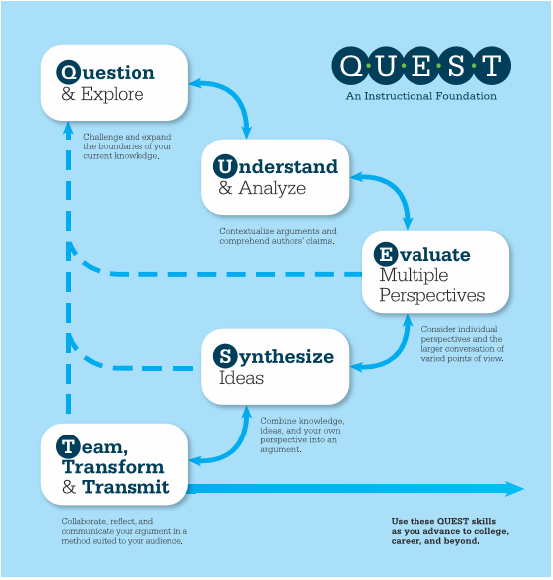
-Taken from the AP Seminar Curriculum Guide.
PARENT CONTACT:
The preferred method of contact for parents is through email. Please allow 24-48 hours for a response. We will also communicate with your student through their school outlook email found in their Microsoft 365 suite on the Classlink server.
MATERIALS:
- Three ring binder/folder
- Highlighter
- Pen/Pencils/Notebook paper

GRADING SCALE:
Letter Grade | Percentage
A | 90-100
B | 80-89
C | 70-79
D | 60-69
F | 0-59

TEACHER GRADING POLICY:
Your grade is calculated based on 100% assessment. Assessment includes tests, quizzes, projects, Socratic seminars, vocabulary assignments, class activities etc. Your work will be graded on a point system. Assignment guidelines are provided including grading rubrics and point values as the course progress.

LATE WORK:
If an assignment is not turned in on time the highest grade possible is a C (you cannot make an ‘A or B’ on a late assignment). Late work will not be accepted after two school days.
Make up work, notes, quizzes, tests, are your responsibility to make up, not mine to find you and compel you to complete
TARDY POLICY:
You are considered tardy for class if you are not sitting in your assigned seat working on the starting assignment when the bell rings.
Every fourth tardy is recorded as a late and are considered an unexcused absence.
MAKEUP WORK:
It is your responsibility to collect and complete assignments for the days you are absent.
When you return after an absence:
- Check the agenda board to see what assignments/activities you missed.
- Check the Makeup work folder (filed by class period) for any handouts or worksheets.
- Make up work should be completed as soon as possible and must be turned in within three days of return for credit.
- If necessary, schedule an appointment to make up a test using the appointment calendar located near the classroom door.

CLASSROOM MANAGEMENT:
I follow the discipline plan as outlined by your student handbook including those regarding tardiness, dress code, and personal electronic devices.
My expectations for this class are for students, parents, and teacher to work together to create a safe and supportive learning environment. I expect sincere effort on all tasks and assignments. I also expect mutual respect from student to teacher as well as from student to student.
ACADEMIC INTEGRITY:
Academic integrity violations can include plagiarism, cheating, and unauthorized group work on any assignment, project, or test.
If a student is caught the following will occur:
- The student will receive an F with zero credit.
- The citizenship grade will be lowered for the grading period.
- A notice will be recorded with the guidance office.

Any occurrence of academic dishonesty may be reported by the guidance office on college admissions applications. In addition, your citizenship grade for the class will be reduced.
There is a zero tolerance policy for electronic devices on assessment days. Any student found with a phone on their person (regardless of the intended use) will receive a grade of zero.

COLLEGE BOARD CAPSTONE PLAGIARISM POLICY:
“A student who fails to acknowledge the source or author of any and all information or evidence taken from the work of someone else through citation, attribution, or reference in the body of the work, or through a bibliographic entry, will receive a score of 0 on that particular component of the AP Seminar and/or AP Research Performance Task. In AP Seminar, a team of students that fails to properly acknowledge sources or authors on the Team Multimedia Presentation will receive a group score of 0 for that component of the Team Project and Presentation.
A student who incorporates falsified or fabricated information (e.g. evidence, data, sources, and/or authors) will receive a score of 0 on that particular component of the AP Seminar and/or AP Research Performance Task. In AP Seminar, a team of students that incorporates falsified or fabricated information in the Team Multimedia Presentation will receive a group score of 0 for that component of the Team Project and Presentation.”

SPECIAL CONSIDERATION:
Public speaking and presentation are a critical component of this course and the AP Capstone Program. For purposes of reflection and assessment students may be asked to record themselves presenting individually or in groups in both practice and formal assessment settings. These recordings will only be used for academic purposes and will not be released by the teacher to entities outside of Leon High School without parent permission.

